Eastern Mediterranean University
Faculty of Arts and Sciences
Department of Chemistry
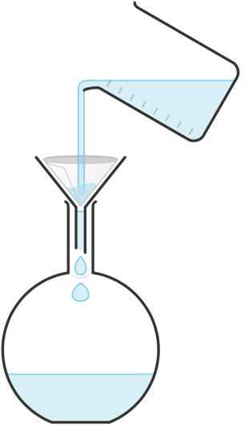

CHEM400 Internship Report
Student’s / Öğrencinin
Name & Last name
Adı ve Soyadı
Student No
Öğrenci No
Period of Internship  Staj tarihleri | From ..... / ..... / 20..... To ..... / ..... / 20.....  Başlama Bitiş
Institution’s / Kurumun
Name
Adı
Address  Addresi | ............................................................................................................  City : ........................... Country : ...........................  Şehir Ülke

ACKNOWLEDGMENTS

[Optinal]

TABLE of CONTENTS

ACKNOWLEDGMENTS 2
TABLE of CONTENTS 3
LIST of FIGURES 4
LIST of TABLES 5
ABSTRACT 6
2. LAYOUT OF THE INTERNSHIP REPORT 8
2.1 Margins 8
2.2 Page numbering 8
2.3 Use of Word-Processors in Preparing a Internship Report 8
2.4 Fonts 8
2.5 Paragraphs 8
2.6 Figures and Equations and Tables 8
All figures must be centered and properly labeled. They must be drawn by using proper computer software of your own choice. The figure captions should be printed using a 10-point proportional font such as Times New Roman with single line spacing. Examine the examples below. 8
2.6.1 An Example Figure Layout 9
2.6.2 An Example of a Chemical Equation Layout 9
2.6.2 An Example Equation Layout 9
2.6.3 An Example Table Layout 10

LIST of FIGURES
Figure 1 ……………………………………………………………………………..5

LIST of TABLES

Table 1 ……………………………………………………………………………..6

ABSTRACT
Summary of what you had learned (not more than 2000 characters)
1. INTRODUCTION

The introduction should contain a concise description of the workplace. A description of the departments you were enrolled in and the kind of work done should also be included. The last section of the introduction subtitled My Internship summarizes the professional aspects of the practice that will be detailed in the main body of the report.

2. LAYOUT OF THE INTERNSHIP REPORT

2.1 Margins

Left margin: 3 cm
Right margin: 2.5 cm
Top margin: 2.5 cm
Bottom margin: 2.5 cm

2.2 Page numbering

Normal page numbering starts from the beginning of Chapter 1.
Pages for the content before chapter 1 are numbered using roman numerals

2.3 Use of Word-Processors in Preparing a Internship Report

Type your report with MS Word.

The user of spell checkers for misspelled words and grammatical mistakes is essential in preparing the report.

All chemical structures must be prepared by using a software like MarvinSketch.

2.4 Fonts

All text throughout the Internship Report should be Times New Roman font with a 12-point size except for the following:
- Chapter heading “Heading 1” should be 14-point font, all capital letters. The chapter heading may be preceded by, say, “Chapter 1” which should be typed using 18-point bold font with small-case letters and first letter capital.
- Section headings in each chapter “Heading 2” should be 12-point bold font, not capital.
- Subsections in each section “Heading 3” should be 12-point italic using Times New Roman or CG scaleable small case font, not bold.

Further details can be seen from the example pages shown in section 4 of the report.

2.5 Paragraphs

Fully justified (extending from left margin to right margin) with 1.5 line spacing .

2.6 Figures and Equations and Tables

All figures must be centered and properly labeled. They must be drawn by using proper computer software of your own choice. The figure captions should be printed using a 10-point proportional font such as Times New Roman with single line spacing. Examine the examples below.

2.6.1 An Example Figure Layout

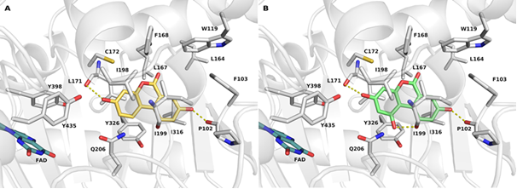
(A)
(B)
Figure 19: Predicted binding modes of compound (A) and compound (B)
Centered

2.6.2 An Example of a Chemical Equation Layout

H₂SO₄ (aq) + 2NaOH (aq) → 2NaCl (aq) + H₂O (l)

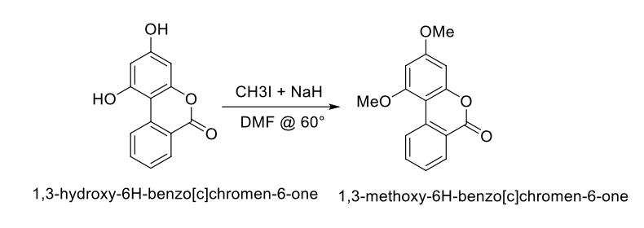

Centered

2.6.2 An Example Equation Layout

Equations must be typed by using the Equation Editor of MS Word.

The equations must be right justified and properly numbered using a parenthesis. An example of the equation layout and referencing in the text is shown below:

The ideal gas equation can be represented by:

$PV=nRT$ (2.1)

Equation number is right aligned
Equation is centered

2.6.3 An Example Table Layout

An example layout for the tables is given below.

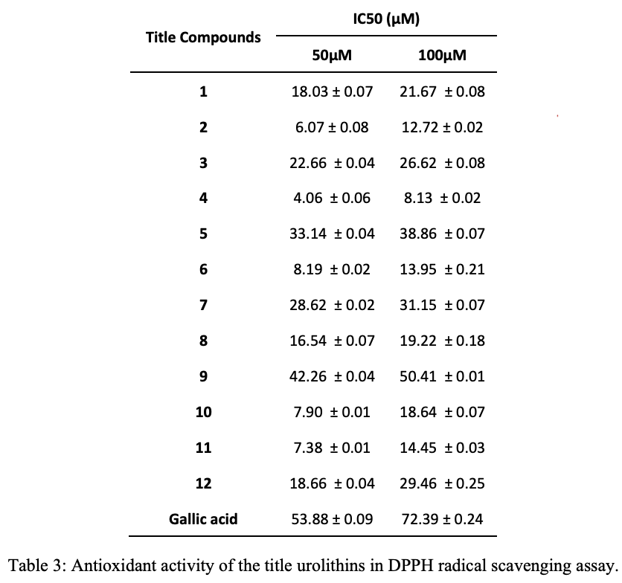
References

Most of the institutions throughout the world abide by the copyright protection laws and therefore avoid using someone else’s work without clearly explaining that the work is done by someone else. If some theoretical material or data sheets etc are referred to in the report, this is done by using reference to the previously published work with a reference number and listing the reference at the end of your work. The following section gives advice and examples on widely used methods of making references in your text and on how to list them at the end of your work.

Please note the different standards for books, journal articles, conference articles, thesis, reports, patents, electronic (URL) pages.

Cited publications are numbered in the order in which they are first referred to in the text. They are identified by a number given as follows:

In a recent study [5] it was shown that...

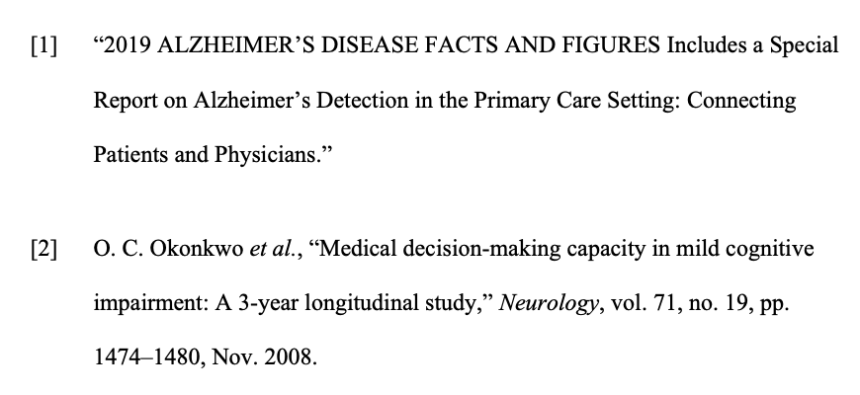
[3] Chemistry Department’s web page: https://chemistry.emu.edu.tr

