Eastern Mediterranean University | Doğu Akdeniz Üniversitesi
Faculty of Arts and Sciences | Fen ve Edebiyat Fakültesi
Department of Chemistry | Kimya Bölümü
Famagusta TRNC | Gazimağusa KKTC

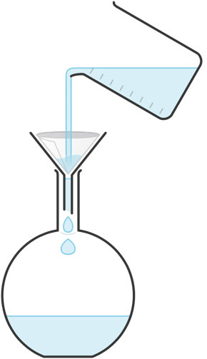

STAJ DEFTERİ
INTERNSHIP LOG BOOK

CHEM400

https://chemistry.emu.edu.tr

Student’s / Öğrencinin
Name & Last name
Adı ve Soyadı
Student No
Öğrenci No
Period of Internship  Staj Tarihleri | From ..... / ..... / 20..... To ..... / ..... / 20.....  Başlangıç Bitiş
Institution’s / Kurumun
Name
Adı
Address  Addresi | ............................................................................................................  City : ........................... Country : ...........................  Şehir Ülke
Web page
İnternet sayfası

TO THE STUDENT

Learning outcomes:
Please be known that the internship you are going to practice will add to your education with
- improved ability to apply knowledge of chemistry,
- improved ability to function on multidisciplinary teams,
- improved understanding of professional and ethical responsibility,
- improved ability to communicate effectively,
- improved ability to use technics, skills, end modern chemical tools necessary for chemists,
- improved skills in design, conduct and management of chemistry experiments,
- improved consciousness and skills on lab safety and waste management.

Instructions:
- The prefferred language for filling out this logbook is English. However, some institutions may prefer another language for validation. Therefore, make sure that you ask the possibility of preparing the logbook in English in the first day of your internship. Consult the Internship Coordinator if the Institution preffers another language.
- Make sure that you learn the preferred language of the logbok from the Institution. If it is other than ENGLISH
- The genuinness / originality of your logbook will be tested by TURNITIN software (with maximum 30% similarity tolerance). Therefore, all information (except the performance evaluation info on the validation and evaluation pages) must be digitally entered by using MS Words. The finished version of the file must be printed and submitted to the institution for validation. Never do any changes on your file after this stage.
- Make sure that the instution sends the signed logbook in an envelope which is securely closed, signed and sealed.
- Prepare a separate “Internship Report” MS Word file by following the guidelines provided.
- Submit both the logbook and internship report through the CHEM400 LMS page for Turnitin originality test and permanent storage in the electronic archive of the University. The deadline for submission of the logbook and the report is two weeks earlier to the beginning of the final exams.
- The printed and wet-signed version of the logbook must be submitted to the Internship Coordinator through the Department Secretary. The deadline for submission of the printed logbook is two weeks after the commence of the courses.
- Prepare a different log book for each institution if you do your internship in two different institutions.
- Your internship will fully or partly cancelled if you fail in:
- having successfully completed 30 work-days in the institution,
- having a “satisfactory” performance evaluation report by the institution,
- submitting the printed version of your logbook in a securely sealed and signed envelope on time (before the last day of submitting the “Incomplete” grades),
- having a logbook and internship report with acceptable content and format,
- having a satisfactory Turnitin report for both the logbook and the report,
- having a satisfactory evaluation report by the Internship Coordinator.
(See the last page for details)

DECLARATION OF THE STUDENT / ÖĞRENCİNİN BEYANI

I declare that all the work shown in this log book was done by myself. I also declare that I have not refered to any other internship report or log book. Any quoted text from the literature has been duly acknowledged.

Bu staj defterinde gösterilen bilgilerin detayları gösterildiği şekilde bilfiil tarafımdan yapıldığını beyan ederim. Staj defterimde yer alan bütün bilgilerin kendim tarafından kaleme alındığını, zorunlu hallerde kullanılan alıntıların kaynakçalarının açıkça yazıldığını, bunlar dışındaki kaynaklardan alıntı yapmadığımı ayrıca beyan ederim.

Student’s
Öğrencinin
Name & Last name : ................................................. Student No: .....................................
Adı-soyadı Öğrenci No

Signature: ..................................... Date : ______ / ______ / 20__
İmza Tarih
VALIDATION PAGE / TASDİK SAYFASI
Dear supervisor,
Since the information on this page will be used to determine the student's CHEM400- Internship grade, internships that are not delivered to the student in a closed and signed-sealed envelope will be deemed invalid. Thank you in advance for your time and effort.
Sayın Kurum yetkilisi,
Bu sayfadaki bilgiler öğrencinin CHEM400- Staj notunun belirlenmesinde kullanılacağı için staj defteri kapalı ve imzalı-mühürlü zarfla öğrenciye teslim edilmeyen stajlar geçersiz sayılacaktır. Ayırdığınız zaman ve gayretleriniz için şimdiden teşekkür ederiz.
Student’s name & Last name
Öğrencinin Adı ve Soyadı

Departments worked - Çalıştığı bölümler
Department  Bölüm / Kısım | Start date  Başlangıç Tarihi | Finish date  Bitiş Tarihi | Number of work days  İş günü sayısı
 |  | Total / Toplam: | ... work days / iş günü

Performance evaluation - Performans değerlendirmesi
 | Grade  Not | Notes  Düşünceler
Attendancy  Devamlılık | ❑A ❑B ❑C ❑D ❑F
Enthusiasm, curiosity and effort to learn  Öğrenme hevesi, merağı ve gayreti | ❑A ❑B ❑C ❑D ❑F
Punctuality  Dakiklik | ❑A ❑B ❑C ❑D ❑F
Attitude towards his/her superior(s)  Amirlerine karşı tavrı | ❑A ❑B ❑C ❑D ❑F
Attitude and behavior towards staff Personele karşı tavrı ve davranışı | ❑A ❑B ❑C ❑D ❑F

The studies mentioned in this booklet were made by the aforementioned student. The student's performance evaluation is as shown.

Bu kitapçıkta belirtilmiş çalışmalar adı geçen öğrenci tarafından yapılmıştır. Öğrencinin performans değerlendirmesi gösterildiği gibidir.

Signature owner’s name & last name: ............................................... Title and/or Duty: ............................................
Onaylayanın adı soyadı Ünvanı ve/veya görevi

Signature & Stamp: .................................. Date ..... / ..... / 20.....
İmza ve Mühür Tarih

Contact info / İletişim bilgileri:
Phone/Tel : .................................... e-mail: ............................................

INSTRUCTIONS for filling out the daily activities /jobs

- The prefferred language is ENGLISH.
Consult the Internship Coordinator for exceptions.

- No hand-writing. Type everything digitally in MS Word.

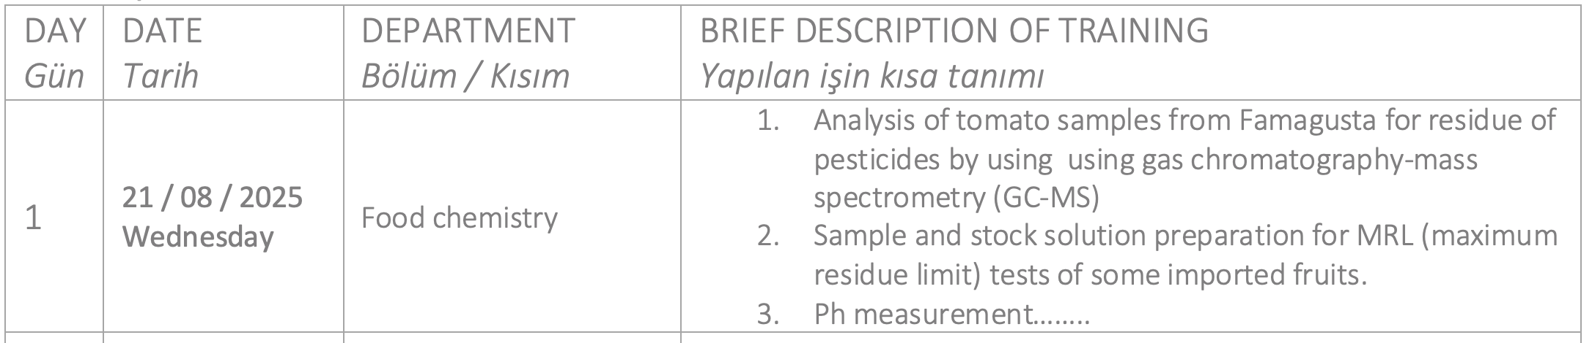
Do not forget to write the day of the week
The description of each item should be as concise as possible and shall not exceed 5 lines. The name of the experiment or technic and the instrument used should be mentioned. Never mind if the table expands to a new page.

Trainings about health safety, ethical issues, waste management etc., shall also be
mentioned.

You can type more than 1 job.
The table will expand automatically to fit the text.

DAY  Gün | DATE  Tarih | DEPARTMENT  Bölüm / Kısım | BRIEF DESCRIPTION OF TRAINING  Yapılan işin kısa tanımı
1 | ..... /..... / 20.....  Day: ..............
2 | ..... /..... / 20.....  Day: ..............
3 | ..... /..... / 20.....  Day: ..............
4 | ..... /..... / 20.....  Day: ..............
5 | ..... /..... / 20.....  Day: ..............
6 | ..... /..... / 20.....  Day: ..............
7 | ..... /..... / 20.....  Day: ..............
8 | ..... /..... / 20.....  Day: ..............
9 | ..... /..... / 20.....  Day: ..............
10 | ..... /..... / 20.....  Day: ..............
(Add more rows or pages when needed)

DAY  Gün | DATE  Tarih | DEPARTMENT  Bölüm / Kısım | BRIEF DESCRIPTION OF TRAINING  Yapılan işin kısa tanımı
11 | ..... /..... / 20.....  Day: ..............
12 | ..... /..... / 20.....  Day: ..............
13 | ..... /..... / 20.....  Day: ..............
14 | ..... /..... / 20.....  Day: ..............
15 | ..... /..... / 20.....  Day: ..............
16 | ..... /..... / 20.....  Day: ..............
17 | ..... /..... / 20.....  Day: ..............
18 | ..... /..... / 20.....  Day: ..............
19 | ..... /..... / 20.....  Day: ..............
20 | ..... /..... / 20.....  Day: ..............
(Add more rows or pages when needed)

DAY  Gün | DATE  Tarih | DEPARTMENT  Bölüm / Kısım | BRIEF DESCRIPTION OF TRAINING  Yapılan işin kısa tanımı
21 | ..... /..... / 20.....  Day: ..............
22 | ..... /..... / 20.....  Day: ..............
23 | ..... /..... / 20.....  Day: ..............
24 | ..... /..... / 20.....  Day: ..............
25 | ..... /..... / 20.....  Day: ..............
26 | ..... /..... / 20.....  Day: ..............
27 | ..... /..... / 20.....  Day: ..............
28 | ..... /..... / 20.....  Day: ..............
29 | ..... /..... / 20.....  Day: ..............
30 | ..... /..... / 20.....  Day: ..............
(Add more rows or pages when needed)

NOTES & COMMENTS (if any) - NOTLAR ve DÜŞÜNCELER (varsa)

EVALUATION PAGE – DEĞERLENDİRME SAYFASI

Student’s
(To be filled by the student)
Name & Last name | ...........................
Student No | ...........................
Period of Internship | From ..... / ..... / 20..... To ..... / ..... / 20.....
Institution’s
(To be filled by the student)
Name | ...........................
Address | ............................................................................................................  City : ........................... Country : ...........................
Web page

Performance assessment:
(To be filled by the Internship Coordinator of the Chemistry Department)
Duration (30 workdays) | Pass Fail (Justification: )
Evaluation of the institution | Pass Fail (Justification: )
Timely submission of the  - printed logbook  - soft copy of the logbook  - soft copy of report | Pass Fail (Justification: )  Pass Fail (Justification: )  Pass Fail (Justification: )
Content and format of the  - logbook  - report | Pass Fail (Justification: )  Pass Fail (Justification: )
Originality (Turnitin report) of the  - logbook  - report | Pass Fail (Justification: )  Pass Fail (Justification: )
OVERALL | Pass  Fail (Justification: )  Incomplete (by work days)
Prof.Dr. Osman YILMAZ
Internship Coordinator

